**Project Design Phase-II**

**Technology Architecture**

|  |  |
| --- | --- |
| Date | 03 October 2022 |
| Team ID | PNT2022TMID27314 |
| Project Name | Smart waste management for metropolitan cities |
| Maximum Marks | 4 Marks |

**Technical Architecture:**

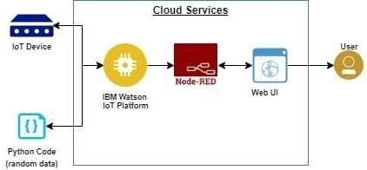

The Deliverable shall include the architectural diagram as below and the information as the table 1&table 2

**Table-1:Components&Technologies:**

|  |  |  |  |
| --- | --- | --- | --- |
| **S.N0** | **Components** | **Description** | **Technology** |
| 1. | User interface | User interact with application using form,login,request notification | Python/HTML/MYSQL/JAVA |
| 2. | Registration | User register in the application to connect bank account | Python/HTML/MYSQL/JAVA |
| 3. | Verification | Verification in the application to connect bank account | Python/HDML/MYSQL/JAVA |
| 4. | Sensor(IOT device) | A device that responds to a physical stimulus (such as heat,light,sound, pressure,magnetism,or a particular motion)and transmit a resulting impulse. | Raspberry pi/Arduino  UNO/Temperature sensor/ultrasonic sensor |
| 5. | Sends notification | Sends the notification to the cloud database | IBM Cloud |
| 6. | Cloud Database (Node Red) | Database service on cloud | Node Red |
| 7. | Application | A computer software package that performs a specific function directly for an end user | IBM Wastson STT service |

**Table-2:Application Characteristics:**

|  |  |  |  |
| --- | --- | --- | --- |
| **S.No** | **Characteristics** | **Description** | **Technology** |
| 1. | Open-Source Framework | Open source is a term denoting that a product includes permission to use its source code,design documents or content. | Bootsrap |
| 2. | Scalable Architecture | It connected with scalable architecture | IBM Watson |
| 3. | Availability | This application access is availble at the work time of the workers according to their corporation or municipality. | Python |
| 4. | Performance | Record resource requests and save registered information.  Availability of application. | IBM Watson |